**Arjava Website Content**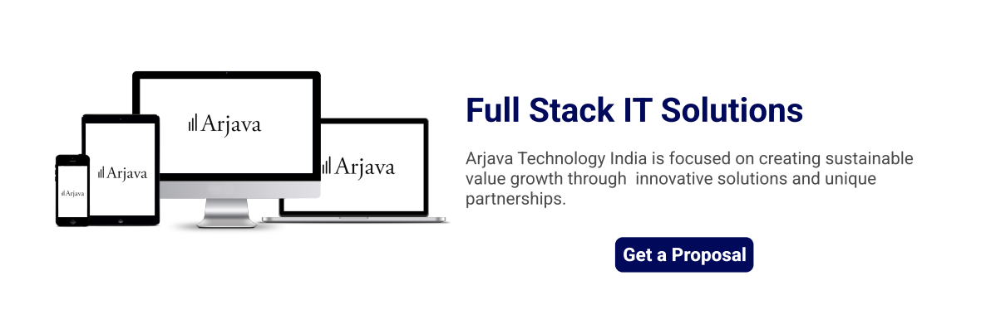

Arjava Technology India is focused on creating sustainable value growth through innovative solutions and unique partnerships.

**Digital Services**

**Mobile Application**

Mobile application development is the set of processes and procedures involved in writing software for small, wireless computing devices, such as smartphones and other hand-held devices.

Application has always been the platform for creativity. we have years of experience in developing robust feature-reach apps with no bugs attached. Our skilled team works with the Android platform using all the flexibility and potential it provides and delivers apps that our client love to use.

**UX/UI Design**

UI (User Interface) and UX (User Experience) are two essential elements in the virtual world. Unless the UI and UX are up to the mark, it’s not possible to reach the audience, perfectly. When you have the best UI/UX, they can elevate your business even in offline situations. Basically, the UI/UX design is a process of designing visual and functional aspects of a product. It is necessary for both hardware or software products.

**Web Application**

We develop web applications that are responsive, intuitive, highly scalable, and can function online or offline as progressive web applications. Our web application development services covers requirement, design, development, testing, quality assurance, and support. Additionally, our team can assist with consultation related to modernizing older architectures or converting to a new web-based architecture that leverages the latest cloud technologies.

**Web Portal Development**

Connect with your customers, clients, or employees on a user-centric web portal. We will help you collect all touchpoints and workflows and design and develop an easy-to-navigate web portal with customized user journeys, integrated services and enterprise software you use.

**Product Maintenance**

The new technologies driving up complexities of software products, constant evolution in the realm of product maintenance is inevitable. It is pivotal to minimize failures and adequately maintain software products to ensure consistency in their performance. Additionally, it is crucial to address that CIO’s are often burdened with maintaining and monitoring mission-critical applications while simultaneously reducing costs. With adequate software maintenance services deployed throughout a product’s lifecycle, businesses can maintain as well as upgrade existing products to ensure market and brand relevance, and in turn, retain customers more effectively.

**SEO**

We integrate a new web product into your digital infrastructure, test it in the real environment and use performance insights for future optimization.

**Development Cycle**

**Plan**

**Define project requirements**

In this stage, it is crucial to perform requirement analysis. Recognize ambiguous and incomplete requirements before it results in a burden.

**Design**

**Brand, Colors and Typefaces**

A design is a plan or specification for the construction of an object or system or for the implementation of an activity or process or the result of that plan or specification in the form of a prototype, product, or process. The verb to design expresses the process of developing a design. In some cases, the direct construction of an object without an explicit prior plan (such as in craftwork, some engineering, coding, and graphic design) may also be considered to be a design activity. The design usually has to satisfy certain goals and constraints; may take into account aesthetic, functional, economic, or socio-political considerations; and is expected to interact with a certain environment.

**Development**

**Software installation and coding**

Development in the software process only begins when you are completely sure of the requirements and onboard with the design and features. The development team starts working on the development of a program by writing the necessary code. Now, the development is carried out in different manners based on the type of software requirements. You will understand it in the software development life cycle models section below. This is the riskiest phase of the software development process. However, being an experienced software development company, we easily understand the requirements and develop a product up to the expectations.

**Testing**

**Product Test**

Testing is the most important phase in Software Development Life Cycle. Here, the group of testers is used to test our product or application code very effectively before the product reach our client. However, being an experienced software development company, we can easily point out and fix the bugs before deadline and deliver a product up to the expectations.

**Pre-launch**

**Multi browser and Maintenance**

After successfully testing the code, the next stage is to deploy the code to the live server. As maintaining and enhancing code in a timely manner ensures that software is built after following complete guidelines.

**Launch**

**Ongoing support begins**

The software product is fully released into the market, the product must be kept operational and maintenance of the product is required. This involves fixing issues and keeping the systems up to date with the latest operating system patches or updates of used third-party software. In case the user base of the software product increases significantly, expansion in the form of additional processing power, memory, and/or database capacity might need to be done to keep the system running smoothly.

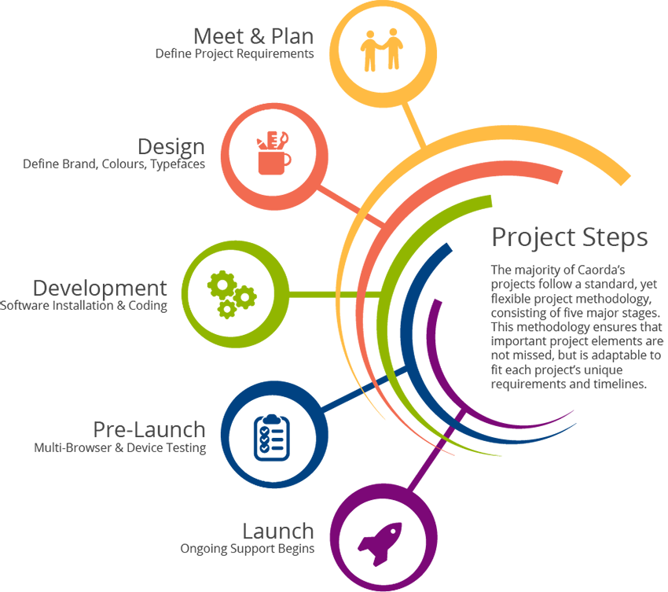

**About Us**

Arjava is an Information Technology Solution Provider that delivers result through effective use of Information Technology.

​​

We have always exploited applicable technology that makes business sense for our clients. With the ability to integrate business, technical and organizational understanding, Arjava helps clients to successfully realize their business objectives.

**Our Services**

At Arjava, we help enterprises expand their businesses by custom application development, Business Intelligence, IT services, testing and mobile application development and Cloud solutions and services that are capable of performing across several platforms and infrastructures.   
  
We have the expertise to provide your organization the enterprise analytics services that you need. We bring out the Business Intelligence that provides meaningful insights that enable decision making based on real-time data. We deliver cutting edge technology solutions customized as per your needs. We work with you to provide end-to-end services to maximize your ROI as you transform your IT environment to move to Cloud Computing.  
  
Our core value revolves around being a well-respected technology company focused on delivering best in class innovative solutions to its customers and partners. We ensure we are a trusted partner of your company and we demonstrate integrity, responsibility and quality in every service we provide. We aim in winning as a team.

**Our Products**

Our creative Team of Software Product developers provides B2B and B2C solutions for customers and end-users. Being aware of the latest market trends as well as constantly communicating with our users – we go beyond traditional software development and create software products that precisely correspond with users’ needs and help them get the most value of using them. We have an innovative approach based on extensive technology expertise, being responsible for full-cycle product development including market research and active product promotion. We develop products on different web and mobile platforms (iOS, Android, Windows, etc) and possess deep experience in creating diverse applications for mobile devices.

**Contact Us**

If you love exploring our creative office plan an appointment and get started the corporate environment.